Wildcard SSL/TLS certificate
# Source: AI Source: Provided by: [Data Path: Persons Table -> ID Column: 1, Name_En Column: Motasem Essam] -> From: [ChatGPT] on [1/18/2026]
A Wildcard SSL/TLS certificate is a certificate that secures a domain and all its first-level subdomains using one single certificate.

🔐 What a Wildcard Certificate Is
# Source: AI Source: Provided by: [Data Path: Persons Table -> ID Column: 1, Name_En Column: Motasem Essam] -> From: [ChatGPT] on [1/18/2026]
- Uses an asterisk (*) as a placeholder for subdomains
- Covers unlimited subdomains at the same level
- Saves cost and management effort
Example
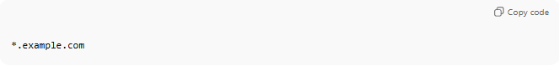
*.example.com
This secures:
- www.example.com
- api.example.com
- mail.example.com
❌ Does not secure:
- example.com (unless included separately)
- sub.api.example.com (second-level subdomain)

🛠️ How It Works
# Source: AI Source: Provided by: [Data Path: Persons Table -> ID Column: 1, Name_En Column: Motasem Essam] -> From: [ChatGPT] on [1/18/2026]
- Certificate is issued for *.example.com
- Browser matches the requested hostname to the wildcard
- If it matches → HTTPS connection is trusted
- Encryption works the same as a normal SSL certificate

📍 Where Wildcard Certificates Are Used
# Source: AI Source: Provided by: [Data Path: Persons Table -> ID Column: 1, Name_En Column: Motasem Essam] -> From: [ChatGPT] on [1/18/2026]
- Websites with many subdomains
- SaaS platforms
- APIs (api.example.com)
- Microservices architectures
- Enterprise environments

🧠 Types of Wildcard Certificates
# Source: AI Source: Provided by: [Data Path: Persons Table -> ID Column: 1, Name_En Column: Motasem Essam] -> From: [ChatGPT] on [1/18/2026]
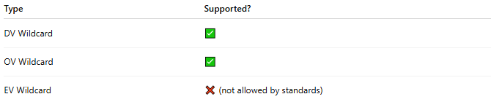
Type | Supported?
DV Wildcard | ✅
OV Wildcard | ✅
EV Wildcard | ❌ (not allowed by standards)

❌ Why EV Wildcard Is Not Allowed
# Source: AI Source: Provided by: [Data Path: Persons Table -> ID Column: 1, Name_En Column: Motasem Essam] -> From: [ChatGPT] on [1/18/2026]
EV (Extended Validation) requires the Certificate Authority to verify and bind the certificate to a specific, fully qualified domain name (FQDN).
A wildcard (*) would:
- Allow unlimited subdomains
- Reduce precise identity binding
- Conflict with EV’s strict identity assurance rules
Because of this, EV + Wildcard is prohibited by the CA/Browser Forum rules.

✅ Advantages
# Source: AI Source: Provided by: [Data Path: Persons Table -> ID Column: 1, Name_En Column: Motasem Essam] -> From: [ChatGPT] on [1/18/2026]
- One certificate for many subdomains
- Easier certificate management
- Cost-effective
- Same strong encryption as regular certificates

⚠️ Disadvantages
# Source: AI Source: Provided by: [Data Path: Persons Table -> ID Column: 1, Name_En Column: Motasem Essam] -> From: [ChatGPT] on [1/18/2026]
- If private key is compromised, all subdomains are at risk
- Doesn’t cover second-level subdomains
- Not ideal for strict security separation

🔒 Best Practices
# Source: AI Source: Provided by: [Data Path: Persons Table -> ID Column: 1, Name_En Column: Motasem Essam] -> From: [ChatGPT] on [1/18/2026]
- Protect the private key carefully
- Use wildcard certs only when subdomains have similar trust levels
- Consider SAN (multi-domain) certificates for complex setups
- Rotate keys periodically

🧠 Authentication Factor
# Source: AI Source: Provided by: [Data Path: Persons Table -> ID Column: 1, Name_En Column: Motasem Essam] -> From: [ChatGPT] on [1/18/2026]
- Something you have → wildcard certificate + private key

One-sentence summary
# Source: AI Source: Provided by: [Data Path: Persons Table -> ID Column: 1, Name_En Column: Motasem Essam] -> From: [ChatGPT] on [1/18/2026]
A Wildcard SSL certificate secures a domain and all its first-level subdomains with a single certificate.

